**DAILY ONLINE ACTIVITIES SUMMARY**

|  |  |  |  |  |
| --- | --- | --- | --- | --- |
| **Date:** | | **10-06-2020** | **Name:** | **Latika Kavoor** |
| **Sem & Sec** | | **4th Sem & A-Section** | **USN:** | **4AL18CS035** |
| **Online Test Summary** | | | | |
| **Subject** | **OOC** | | | |
| **Max. Marks** | **30** | | **Score** | **14** |
| **Certification Course Summary** | | | | |
| **Course** | | **Introduction to IoT** | | |
| **Certificate Provider** | | **CISCO** | **Duration** | **20 hrs** |
| **Coding Challenges** | | | | |
| **Problem Statement:** Write a Java Program to find total number of subarrays which start and end with the same element. | | | | |
| **Status: Completed** | | | | |
| **Uploaded the report in Github** | | | **Yes** | |
| **If yes Repository name** | | | <https://github.com/alvas-education-foundation/latika.kavoor/tree/master/coding_solutions> | |
| **Uploaded the report in slack** | | | **Yes** | |

Online Test Details: (Attach the snapshot and briefly write the report for the same)

OOC TEST 4 was conducted on 10-06-2020. It was for 30 marks. There were 15 questions for 2 marks.

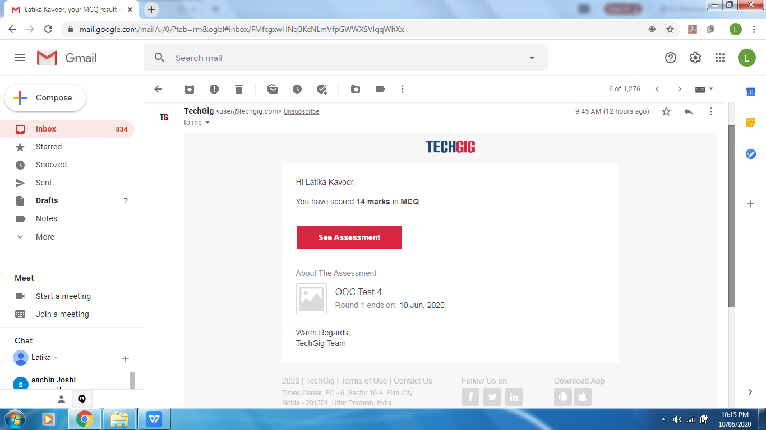

Certification Course Details: (Attach the snapshot and briefly write the report for the same)

I started with Introduction of IoT course yesterday from CISCO. I completed it and got the certificate also for the same.

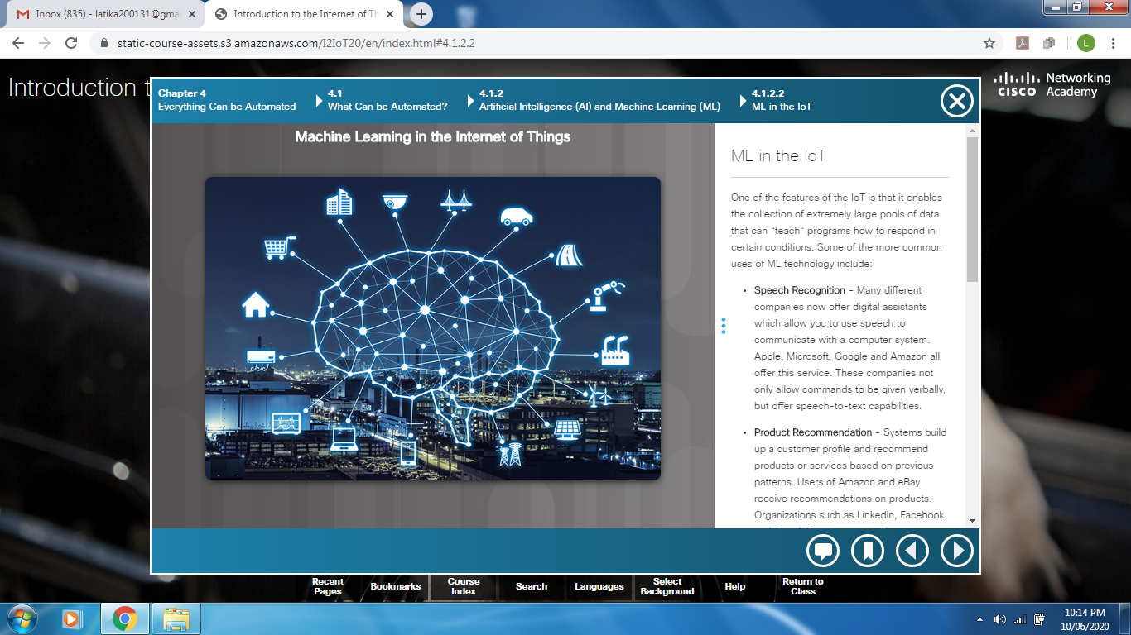

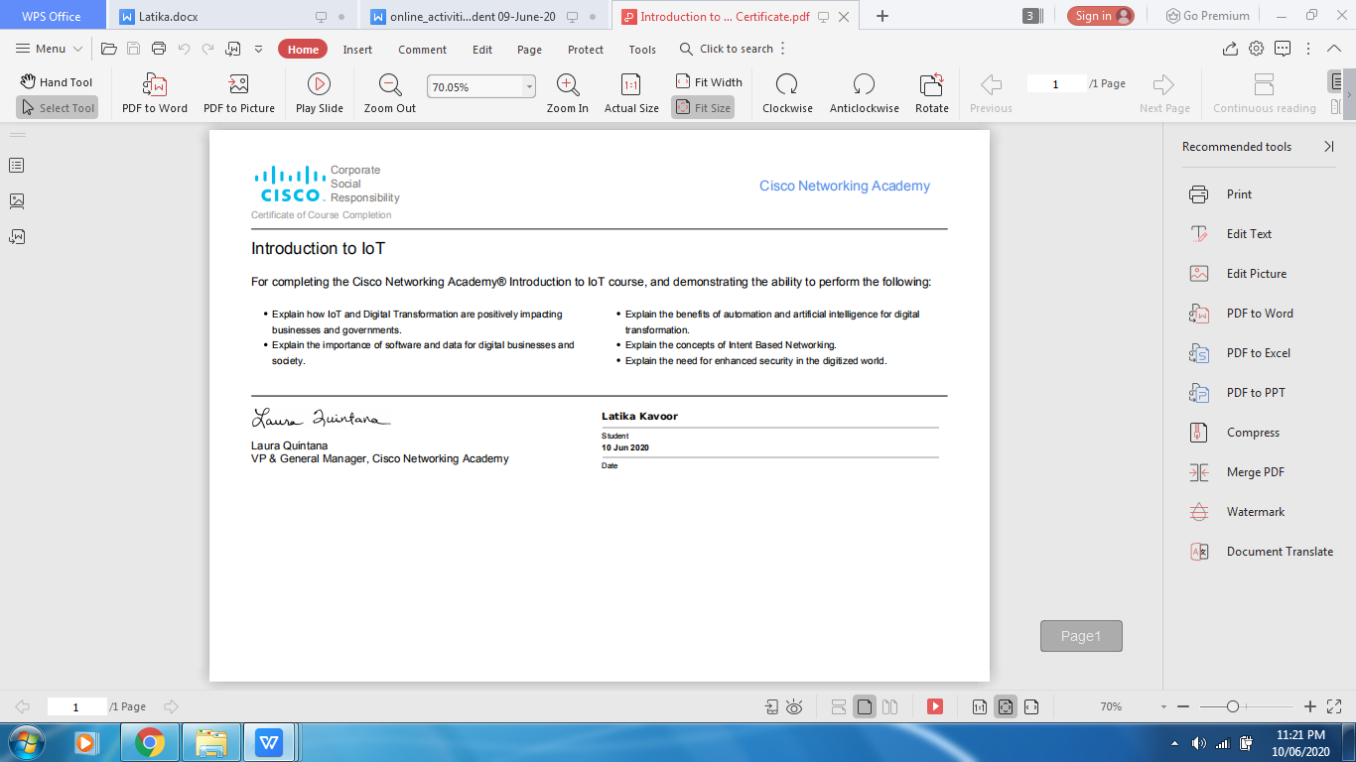

Coding Challenges Details: (Attach the snapshot and briefly write the report for the same)

Solved the problem and uploaded the same on github

